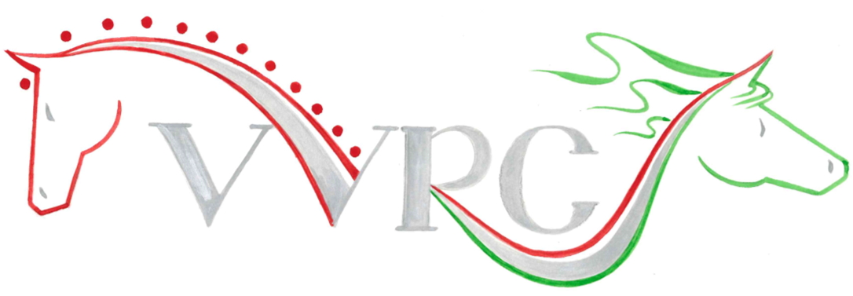

SUMMER Dressage League

DRESSAGE COMPETITION
SUNDAY 19th APRIL 2026
STARTS 10AM
at RADFORDS EQUESTRIAN CENTRE, LLANYMYNECH, SY22 6LG
INTRO 1 (2024)
INTRO 4 (2024)
PRELIM 2 (2024)
PRELIM 3 (2024)
NOVICE 2 (2024)
NOVICE 3 (2024)
ELEMENTARY 1 (2024)

Entries: members £12 for 1st test, £10 for 2nd test. (On same horse). Non-Members £14 for first test, £12 second test (on same horse) Rosettes to 6th place.
Casual but tidy riding wear
Entries to maureencoxon@gmail.com Entries close TUESDAY 14TH APRIL
BACs payment: Vyrnwy Valley Riding Club
Sort code 40-35-32
Account No. 71311735

